Project Name: PhonePe Pulse Geo Payments Intelligence System

Problem Statement
India’s digital payments ecosystem generates massive volumes of PhonePe transaction data across states, districts, and time periods, but raw repository files are not directly actionable. The objective is to transform this data into a geo-enabled analytics system that reveals transaction trends, regional performance, user behavior, and growth patterns to guide product, marketing, and partnership strategies
Key Steps in Project Execution
- Data Wrangling & Cleaning
- Consolidated preprocessed PhonePe Pulse files into a single fact table with fields such as: Date, Year, Quarter, State, District, Transaction_Count, Transaction_Value, User_Count.
- Standardized geography names, validated numeric fields, handled missing or inconsistent records, and derived time attributes (Month, Month-Year).
- Feature Engineering
- Created additional columns for:
  - Region (North/South/East/West) based on State.
  - Value Band (Low/Medium/High) by Transaction_Value.
  - Growth metrics such as YoY_Value_Growth% and Transaction_Frequency per User.
Graphs & Visualizations
- Bar Chart: Total Transactions by State
Shows total transaction volume per state, highlighting top contributors and long tail regions; built as a clustered column chart similar to your “Total Revenue by Product Category” visual.
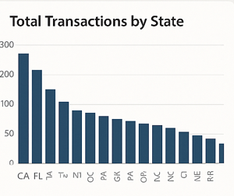
- Map: Geo Distribution of Transaction Value
A filled map visual with states colored by Sum(Transaction_Value) and tooltips for Transaction_Count and User_Count to identify high-intensity payment corridors.
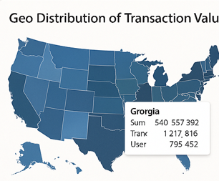

- Line Chart: Monthly Transaction Value Trend
Displays the national time-series of total transaction value by Month-Year to capture growth and seasonality (festive peaks, dips, and structural uptrends).
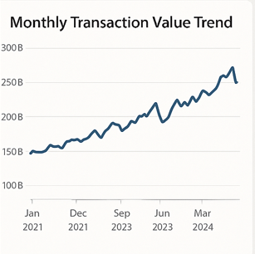

- Donut/Pie Chart: Share by Region
Breaks down total transaction value into North, South, East, and West regions to compare regional contribution and focus areas.
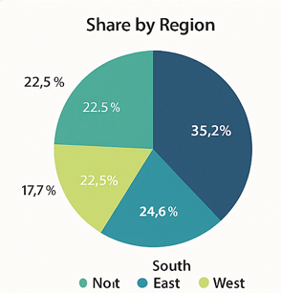

Excel Formulas for Metrics & Visuals
Assume your raw data is in a table named PhonePe_Data with columns:
[Date], [Year], [State], [Transaction_Count], [Transaction_Value], [User_Count].
A. Basic Aggregations (using SUMIFS)
- Total Transaction Value for a specific year (e.g., 2021)
=SUMIFS(PhonePe_Data[Transaction_Value], PhonePe_Data[Year], 2021)
- Total Transaction Value by State (in a summary table)
If A2 holds the State name and B1 holds the Year:
=SUMIFS(PhonePe_Data[Transaction_Value],
PhonePe_Data[State], $A2,
PhonePe_Data[Year], $B$1)
- Total Transaction Count by State/Year:
=SUMIFS(PhonePe_Data[Transaction_Count],
PhonePe_Data[State], $A2,
PhonePe_Data[Year], $B$1)
B. YoY Growth % (for Transaction Value)
If C3 = Current Year Value and C2 = Previous Year Value for the same State:
=IF(C2=0, "", (C3 - C2) / C2)
Format the cell as Percentage for a YoY growth metric.
C. CAGR (Compound Annual Growth Rate)
If C2 = Value in first year, C5 = Value in last year, and there are n years total (for example, 4):
=((C5 / C2) ^ (1 / (4 - 1))) - 1
Replace 4 and 1 with your actual year count and offset.
D. Average Ticket Size
Average transaction value per transaction:
=SUM(PhonePe_Data[Transaction_Value]) / SUM(PhonePe_Data[Transaction_Count])
Or by State (using SUMIFS over filtered state and year).
E. Top N States (Helper for chart)
Create a summary table of State and Total Transaction Value using SUMIFS or a PivotTable, then apply Excel’s “Top 10” filter or use:
=LARGE($C$2:$C$30, ROWS($E$2:E2))
to get top values and then match back to states with INDEX/MATCH.

Advanced Analysis
- Regional Growth Mapping: Compare YoY_Value_Growth% across states and regions to classify them into high-growth, stable, and lagging clusters for targeted initiatives.
- User Engagement Profiling: Analyze Transactions per User by geography to distinguish markets with heavy usage from those with low engagement despite a large base.
- Seasonality & Event Impact: Track Month-Year trends to understand festival-driven spikes and design campaigns and capacity planning around these peaks.

Operational Recommendations
- Prioritize marketing and merchant acquisition in “rising” states showing strong YoY growth but still mid-level transaction value, as these represent scalable opportunities.
- In mature, high-value states, focus on retention, cross-sell, and new use cases (bills, investments, insurance) to deepen engagement rather than only acquisition.
- Institutionalize this PhonePe Pulse dashboard as a standard review tool for regional business teams, with monthly refreshes and standardized KPI views.

Data Structure Overview
- Fact_Transactions: Date_Key, Geo_Key, Transaction_Count, Transaction_Value, User_Count.
- Dim_Date: Date_Key, Date, Year, Quarter, Month, Month-Year.
- Dim_Geography: Geo_Key, State, District, Region.
This star schema supports drill-down from India → State → District and Year → Quarter → Month in Excel, Power BI, or Tableau.

Summary of Insights
- Digital payments via PhonePe are growing strongly across India, with a concentration of value in a few high-intensity states and districts.
- Geo and time-based analysis reveals clear regional leaders, emerging markets, and seasonality patterns, guiding where to invest in growth vs. consolidation.
- The combination of structured data model, Excel/BI formulas, and interactive visuals creates a reusable analytics asset for continuous monitoring of the PhonePe ecosystem.

